ELEC-2110

Electric Circuit Analysis

FROM: Jacob Howard

TO: Markus Kreitzer

DATE: February 5, 2020

LAB SECTION: 002

***Recitation & MultiSim:***

***Thevenin’s and Norton’s Theorems***

# Introduction

The Objective of this lab was to practice more with Multisim. We use Multisim and Thevenin’s and Norton’s theorem to calculate voltage and resistance in various circuits.

# Exercise 1

In exercise 1, we were asked to Use Thevenin’s theorem to find V0 in the circuit shown in Figure 1 and to use MultiSim to verify the answer [1]. Figure 2 shows the circuit constructed in MultiSim and Figure 3 shows the circuit broken to measure the nodes. The data is show belowin Chart 1. Worked out solutions are shown in Solutions 1.

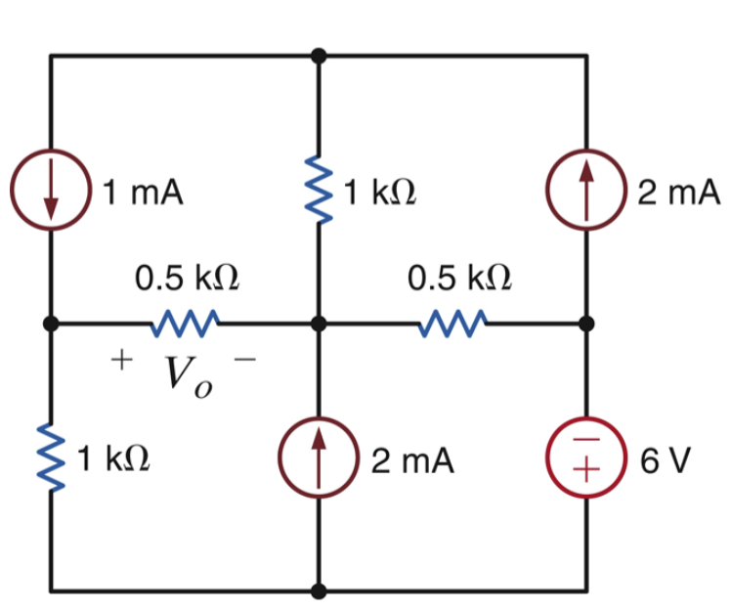

*Figure 1*

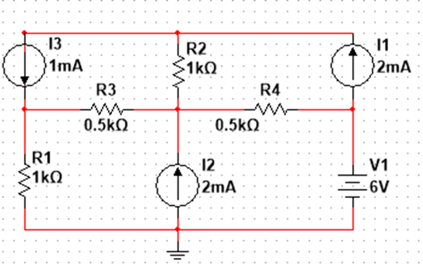

*Figure 2*

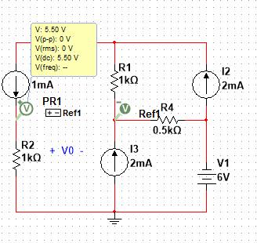

|  |  |
| --- | --- |
| **Voc** | 5.5v |
| **V0** | 1.374v |
| **RTH** | 1.5 k Ohms |

*Figure 3*

*Table 1*

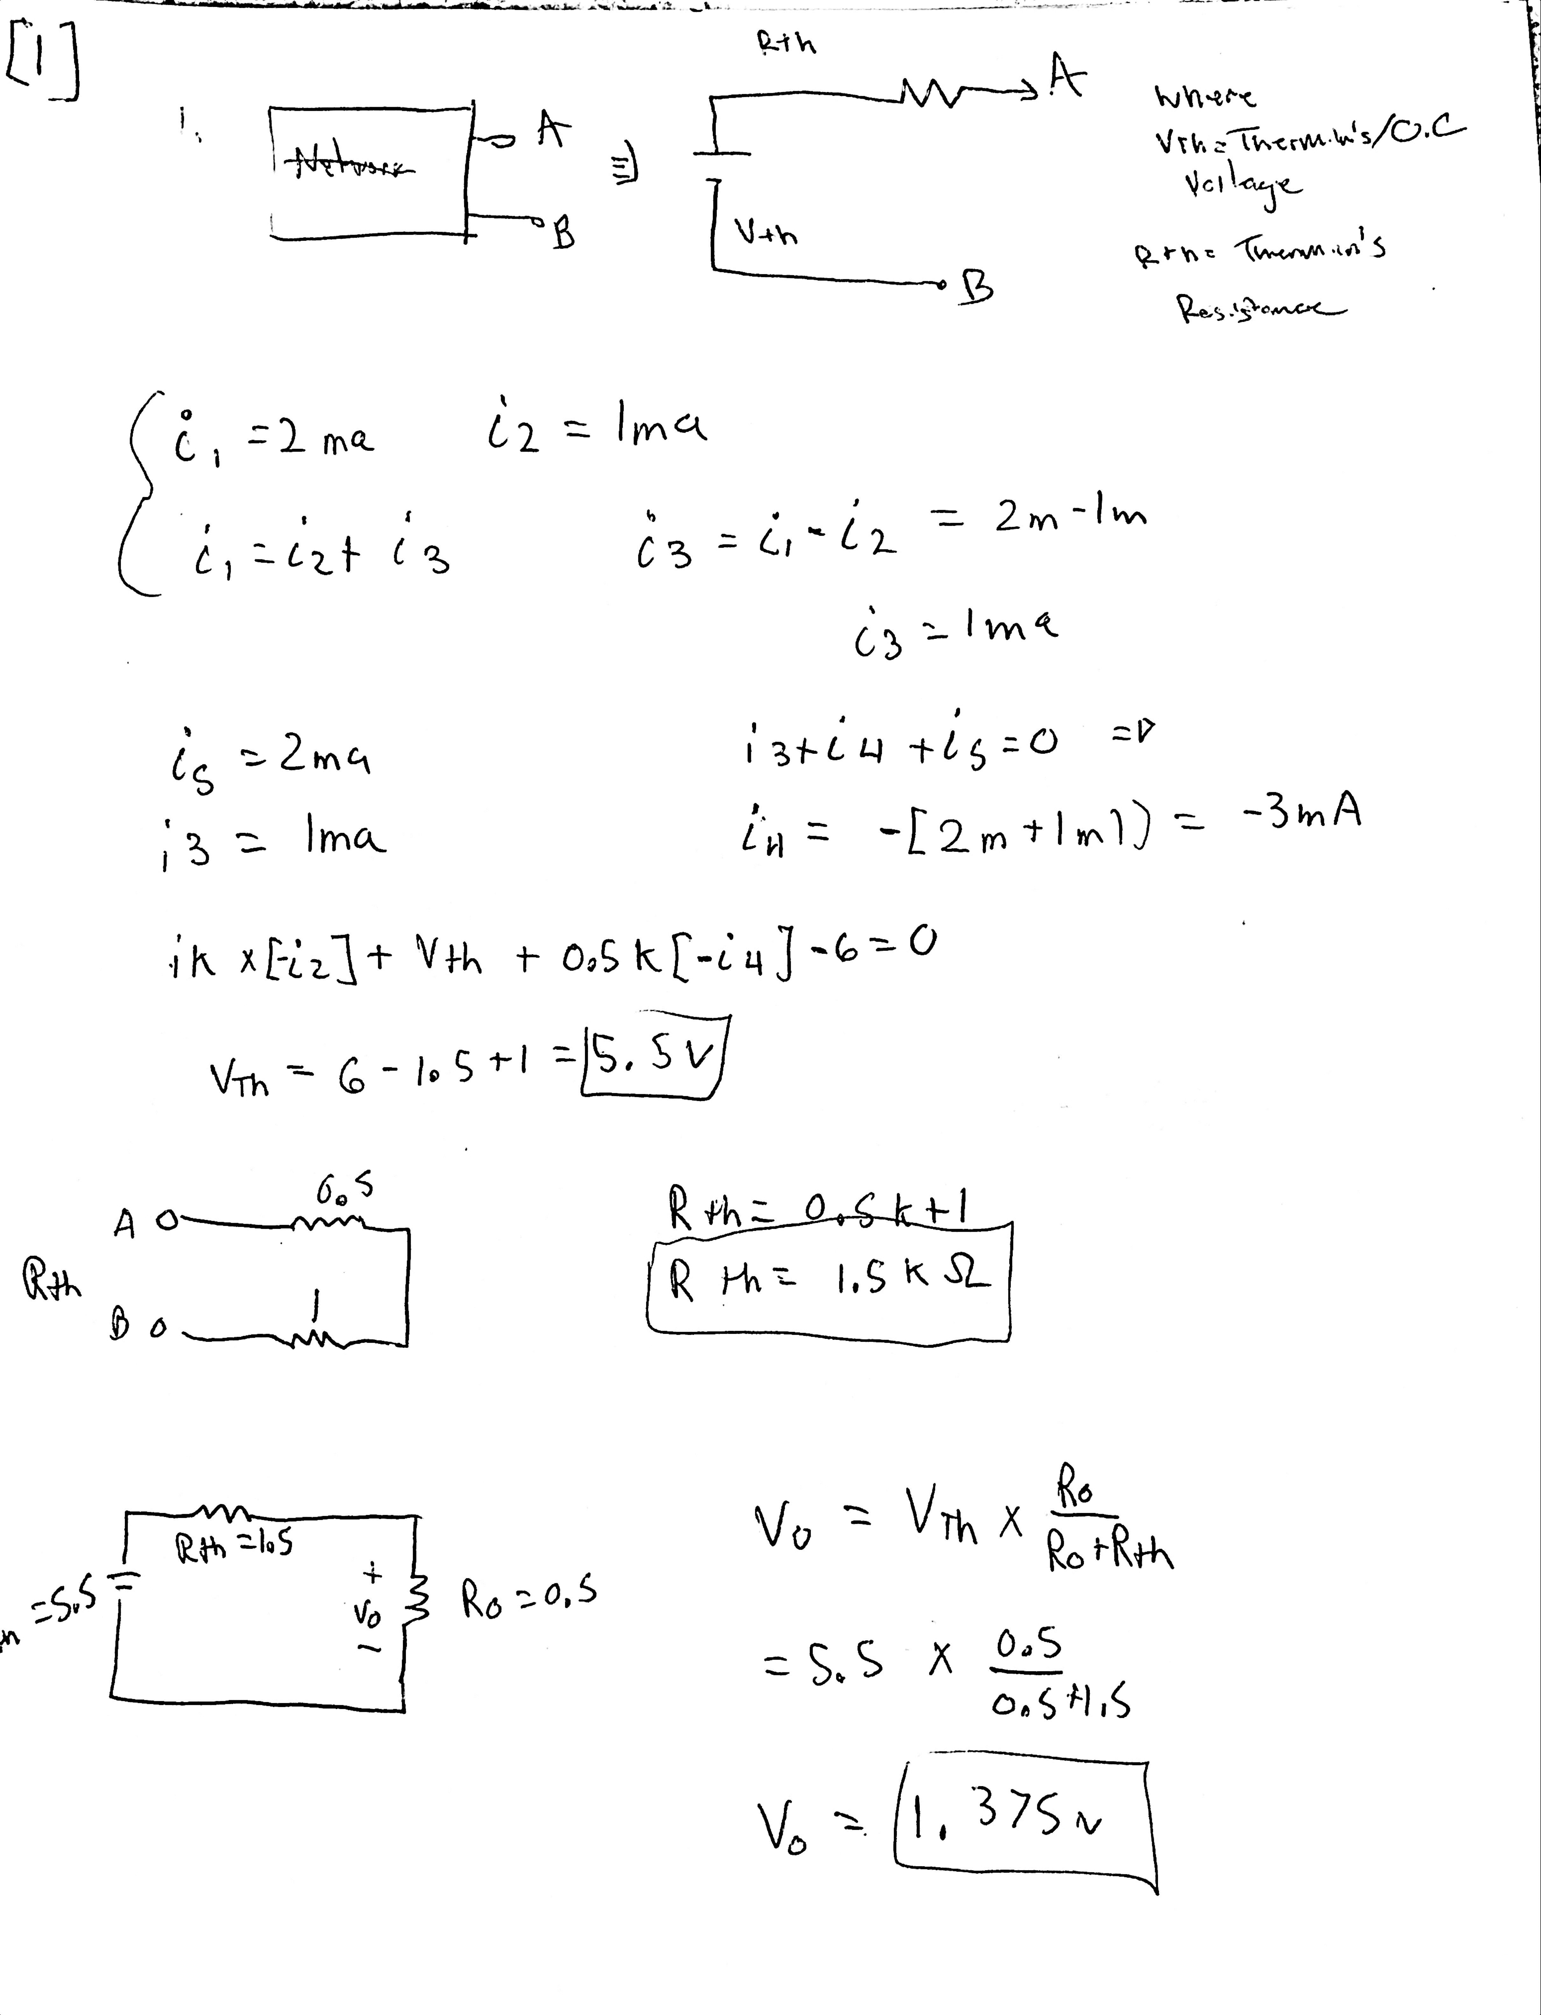

*Solutions 1*

# Exercise 2

In exercise 2, we were asked to find RL for maximum power transfer and the maximum power that can be transferred to RL (Pmax) from figure 4 [1]. The constructed circuit in Multisim is seem in Figure 5 and the Graph to show Pmax is shown in graph 1 (Y1 represents Pmax on the graph).

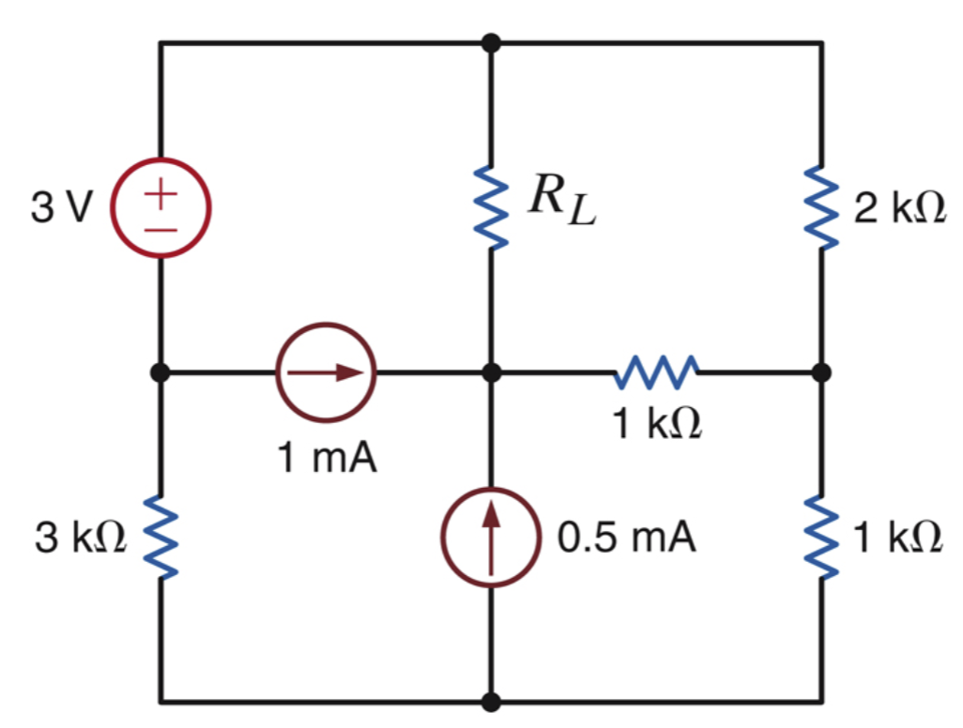

*Figure 4*

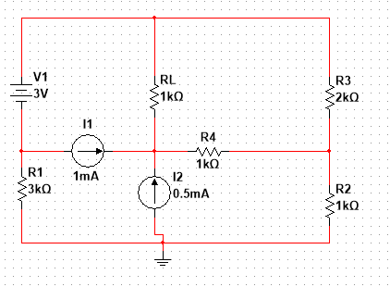

*Figure 5*

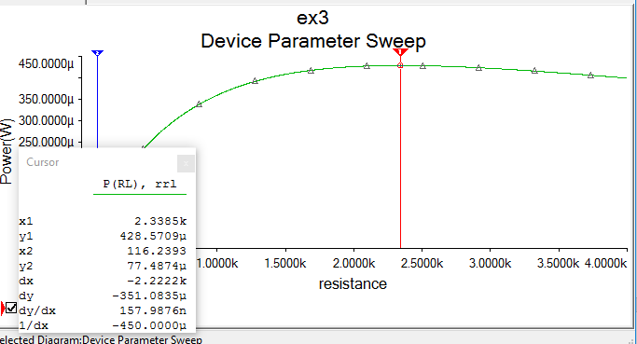

*Graph 1*

# Exercise 3

In exercise 3, we were asked to use Thevenin’s theorem to find Vx in the circuit shown in Figure 5. The circuit constructed in MultiSim to verfify V0 is shown in figure 6. V0 is shown in Table 2. Worked out solutions are shown in Solutions 2 [1].

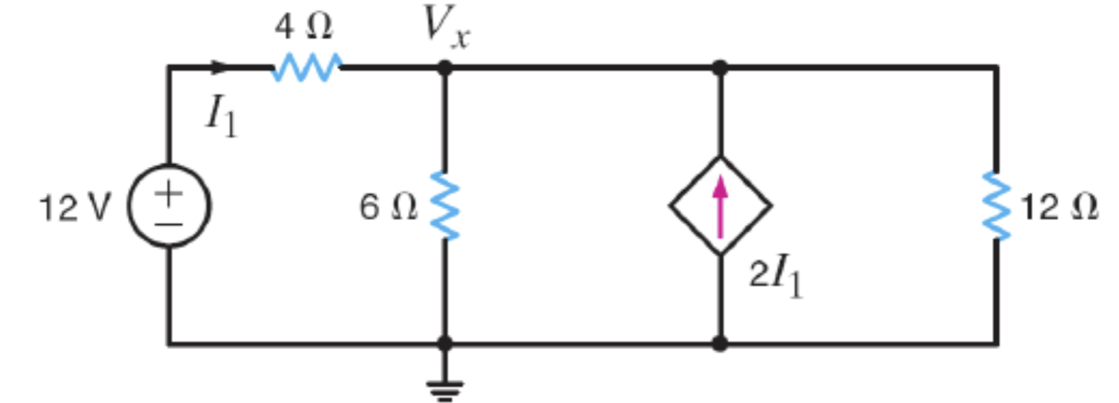

*Figure 5*

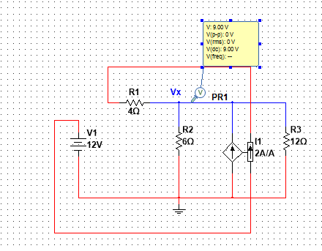

*Figure 6*

|  |  |
| --- | --- |
| **V0** | 9.00v |

*Table 2*

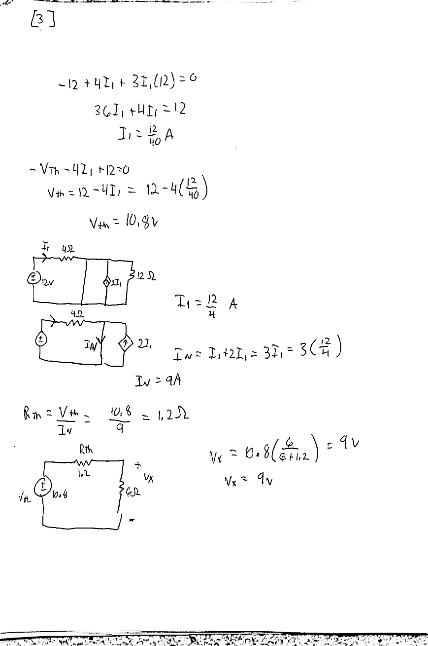

*Solutions 2*

# Exercise 4

In exercise 4, we were asked to find the Thevenin equivalent circuit between nodes A & B for the circuit shown in Figure 6. The circuit constructed in Multisim to verify Ix is shown in figure 7. Worked out solutions are shown in solutions 3[1].

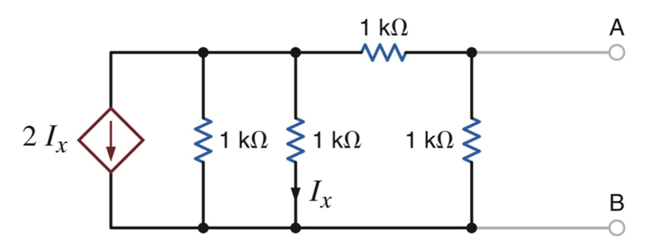

*Figure 6*

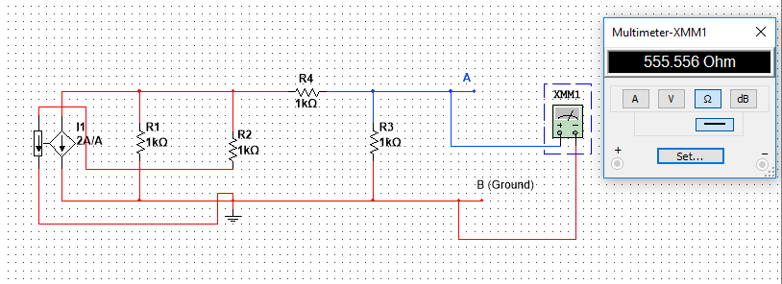

*Figure 7*

|  |  |
| --- | --- |
| **Calculated Resistance for Ix** | 555 Ohms |
| **Measured Resistance for Ix** | 555.556 Ohms |

*Table 3*

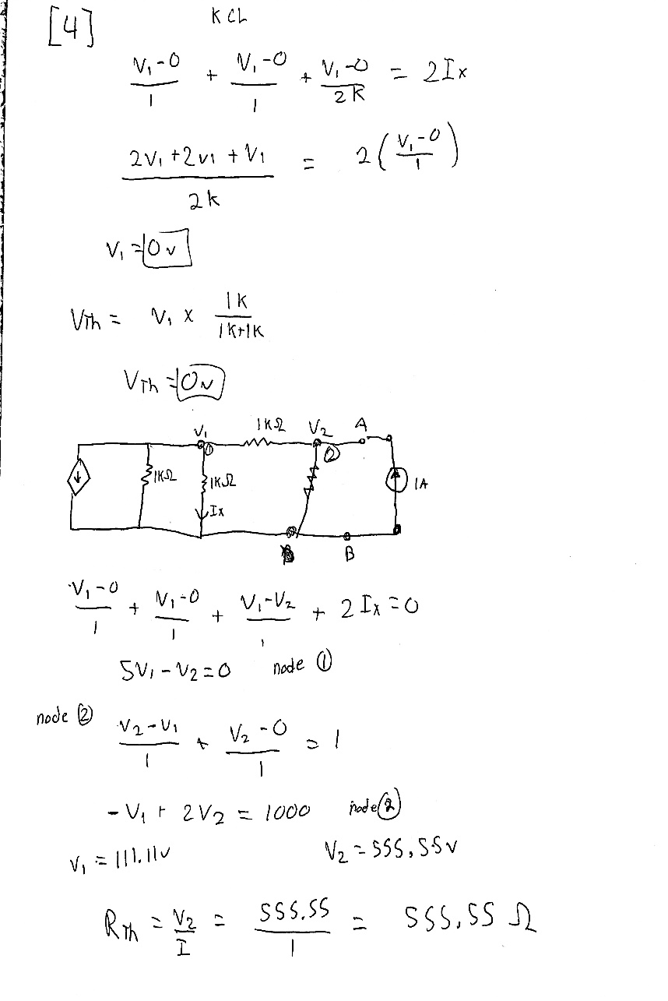

*Solutions 3*

# Exercise 5

In exercise 5, we were asked to find RL for maximum power transfer and the maximum power that can be transferred to RL (Pmax). Pmax is shown in graph 2 below. The circuit is shown below in Figure 8 and the constructed circuit is shown in figure 9. Data is shown in table 4 and solutions are shown in Solutions 4 [1].

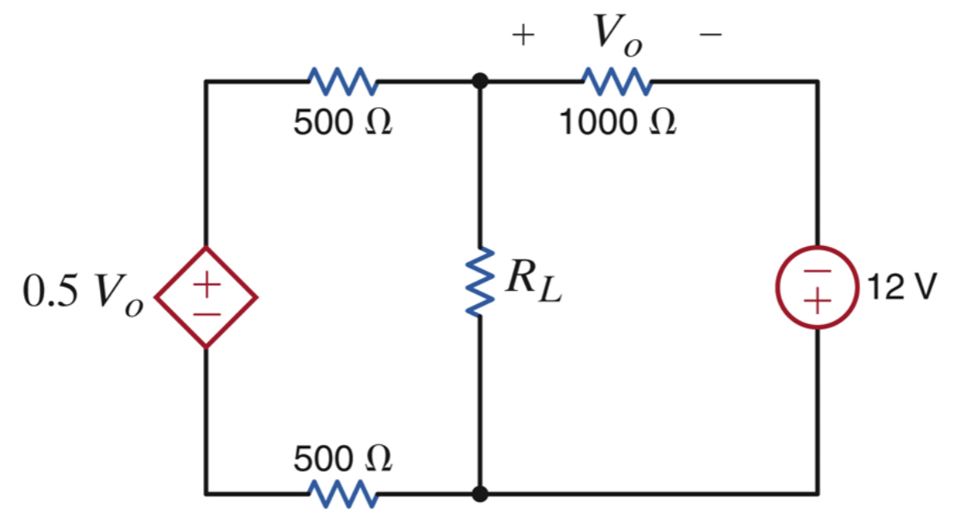

*Figure 8*

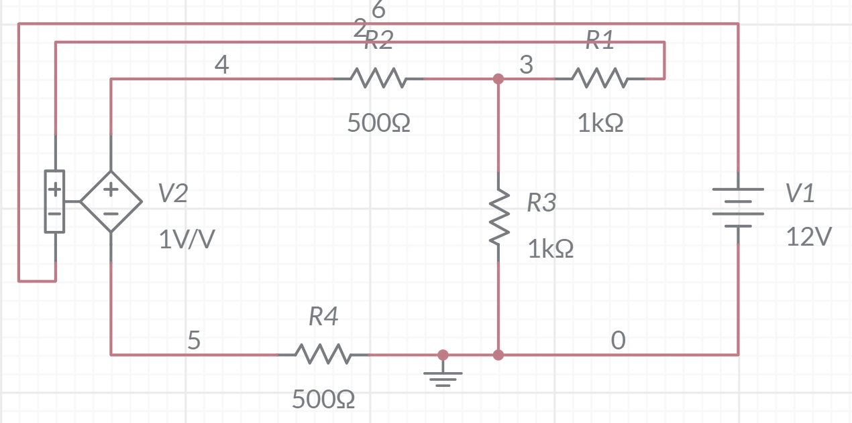

*Figure 9*

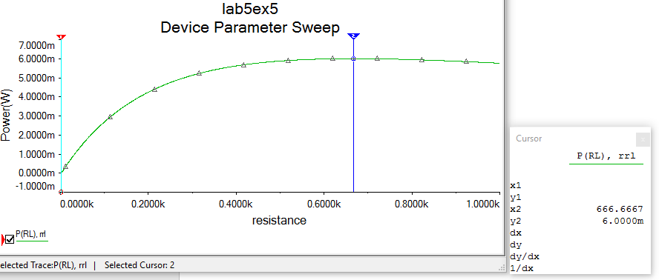

*Graph 2*

|  |  |
| --- | --- |
| **V0** | 8v |
| **VTh** | -4v |
| **I** | 8mA |
| **PRL** | 6mW |

*Table 4*

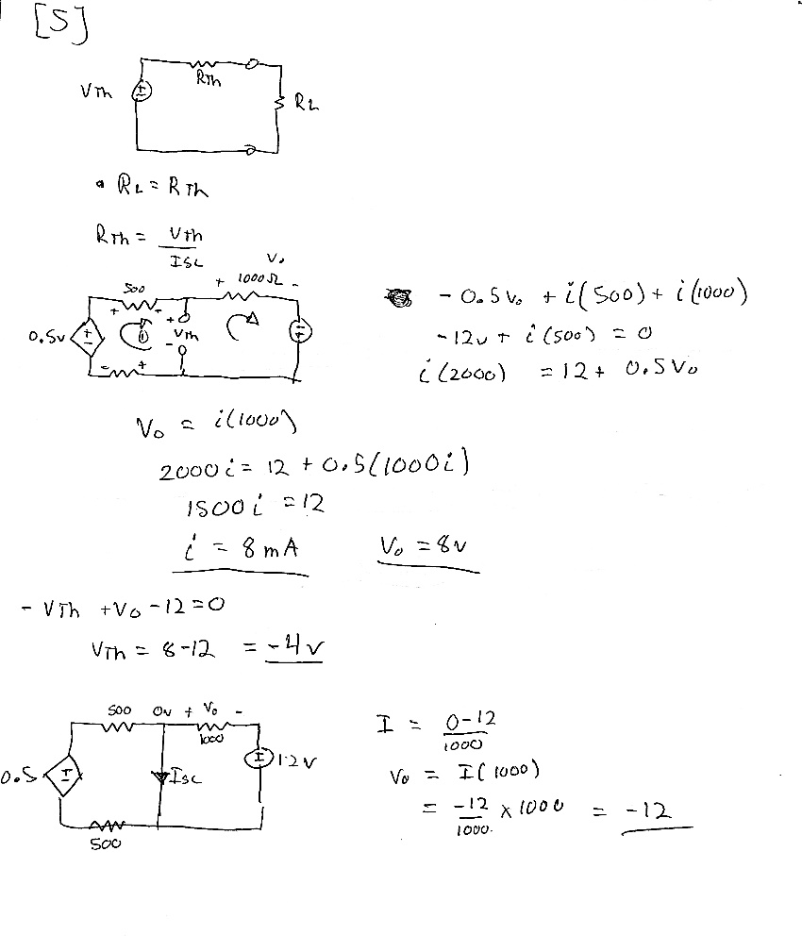

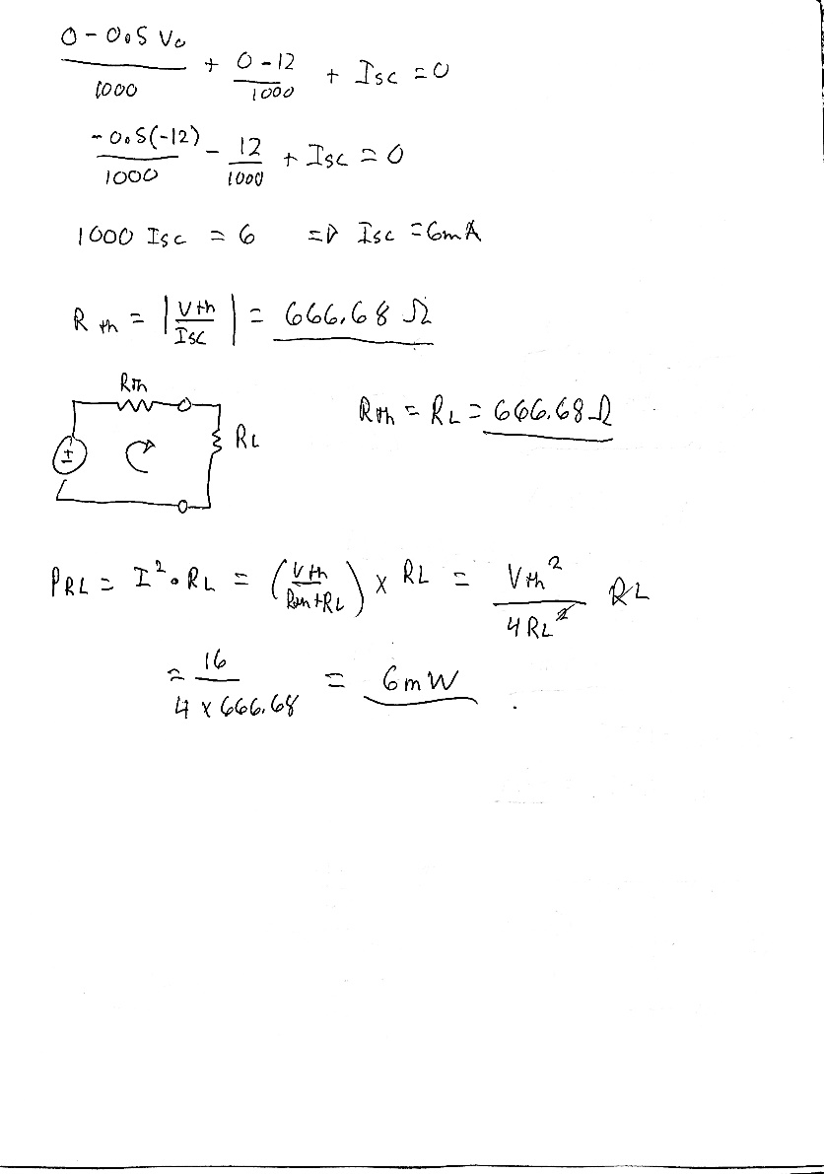

*Solutions 4*

# Conclusion

This lab was used as an overview of Thevenin’sand Norton’s theorem. We were given circuits and asked to calculate various things using Thevinin equations and then verify it through Multisim. I did have some struggles with this lab. The TA helped explain some things before we started so the lab was more clear and helped with some miscalculations.

# Bibliography

[1] Nelms, R. Mark, and Elizabeth Devore. *Recitation & MultiSim: Thevenin’s and Norton’s Theorems*. 2016, p. 5, Accessed 5 Feb 2020.